Table of Contents

Configure Eclipse for Running Cucumber Automation Project 1

**Step1**: Install eclipse natural 0.7.6 plugin 1

**Step2**: Install Cucumber eclipse plugin 2

Step3: install TESTNG Eclipse plugin 3

Access Cucumber Automation project via git repository 5

Running Cucumber Automation Project 9

Step1: Expand and View Project structure 9

Step2: Executing Cucumber test via Junit 9

Step3: Executing Cucumber test via TestNG 9

Step4: Normal Execution and Junit Result 10

Step5: View Test Execution report using Extents Report feature. 11

# Configure Eclipse for Running Cucumber Automation Project

## **Step1**: Install eclipse natural 0.7.6 plugin

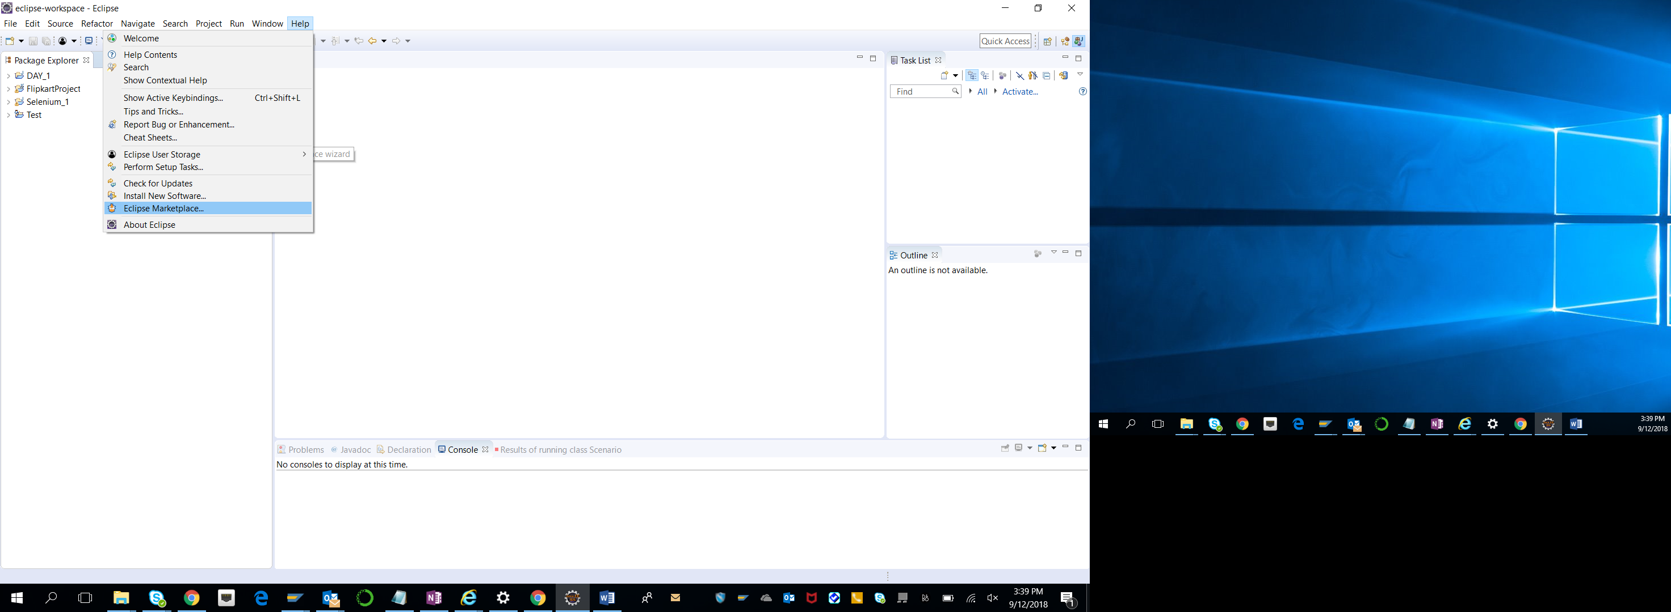

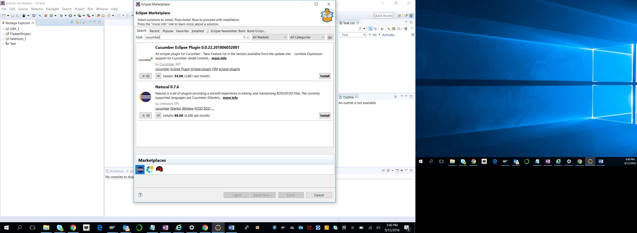

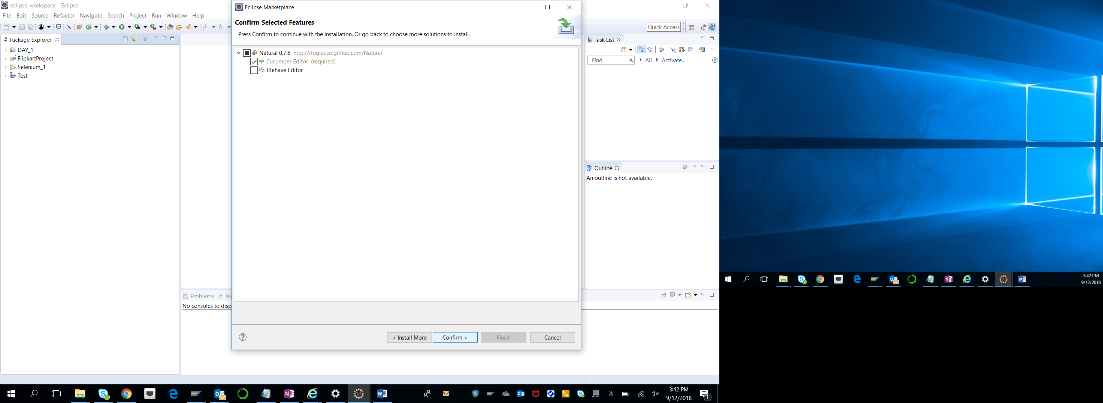

Click on Confirm button

Accept term of installation

Accept any certificate popup.

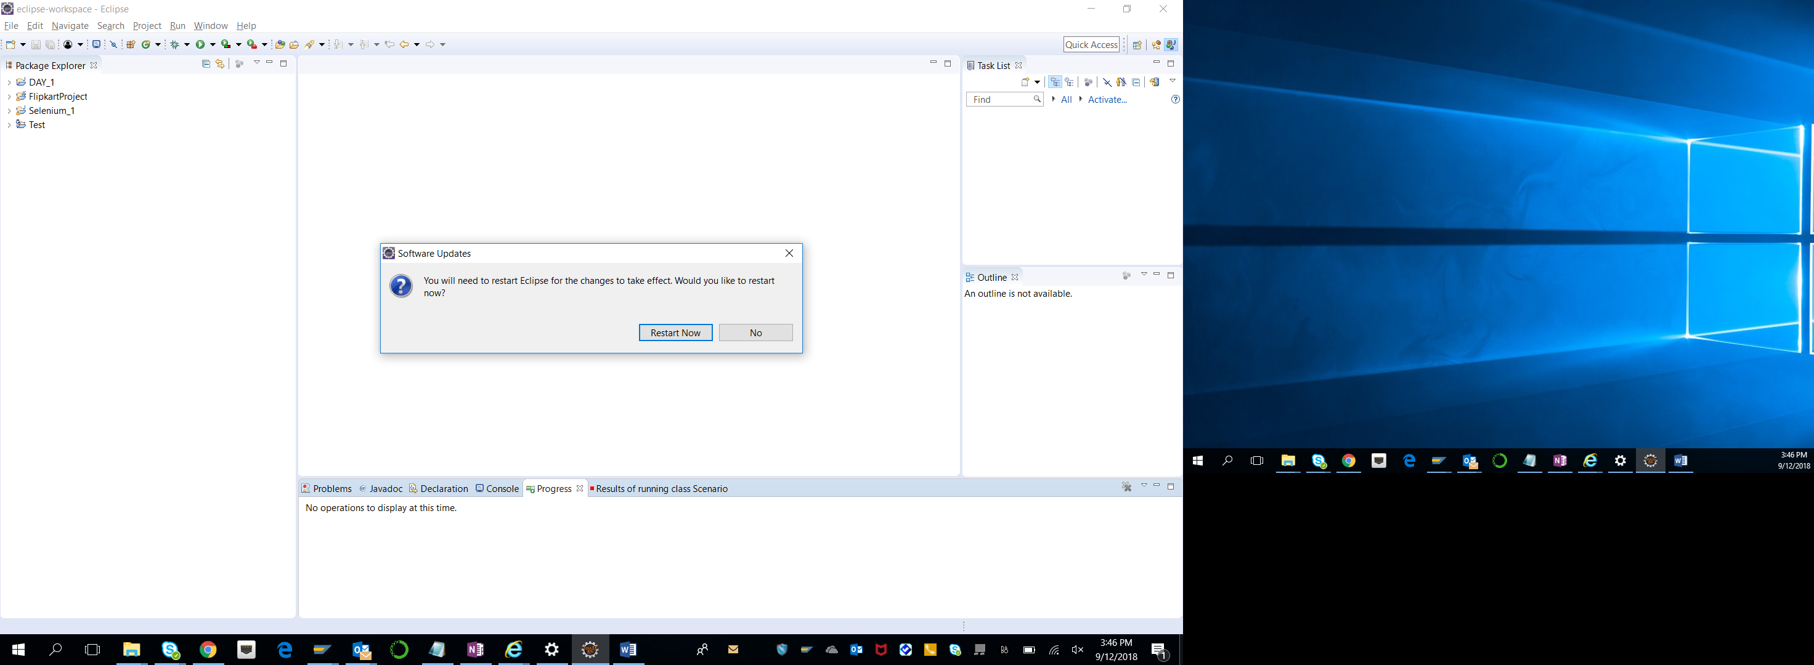

And finally restart eclipse whenever asked.

## **Step2**: Install Cucumber eclipse plugin





Accept term of installation

Accept any certificate popup.



And finally restart eclipse whenever asked.

## Step3: install TESTNG Eclipse plugin

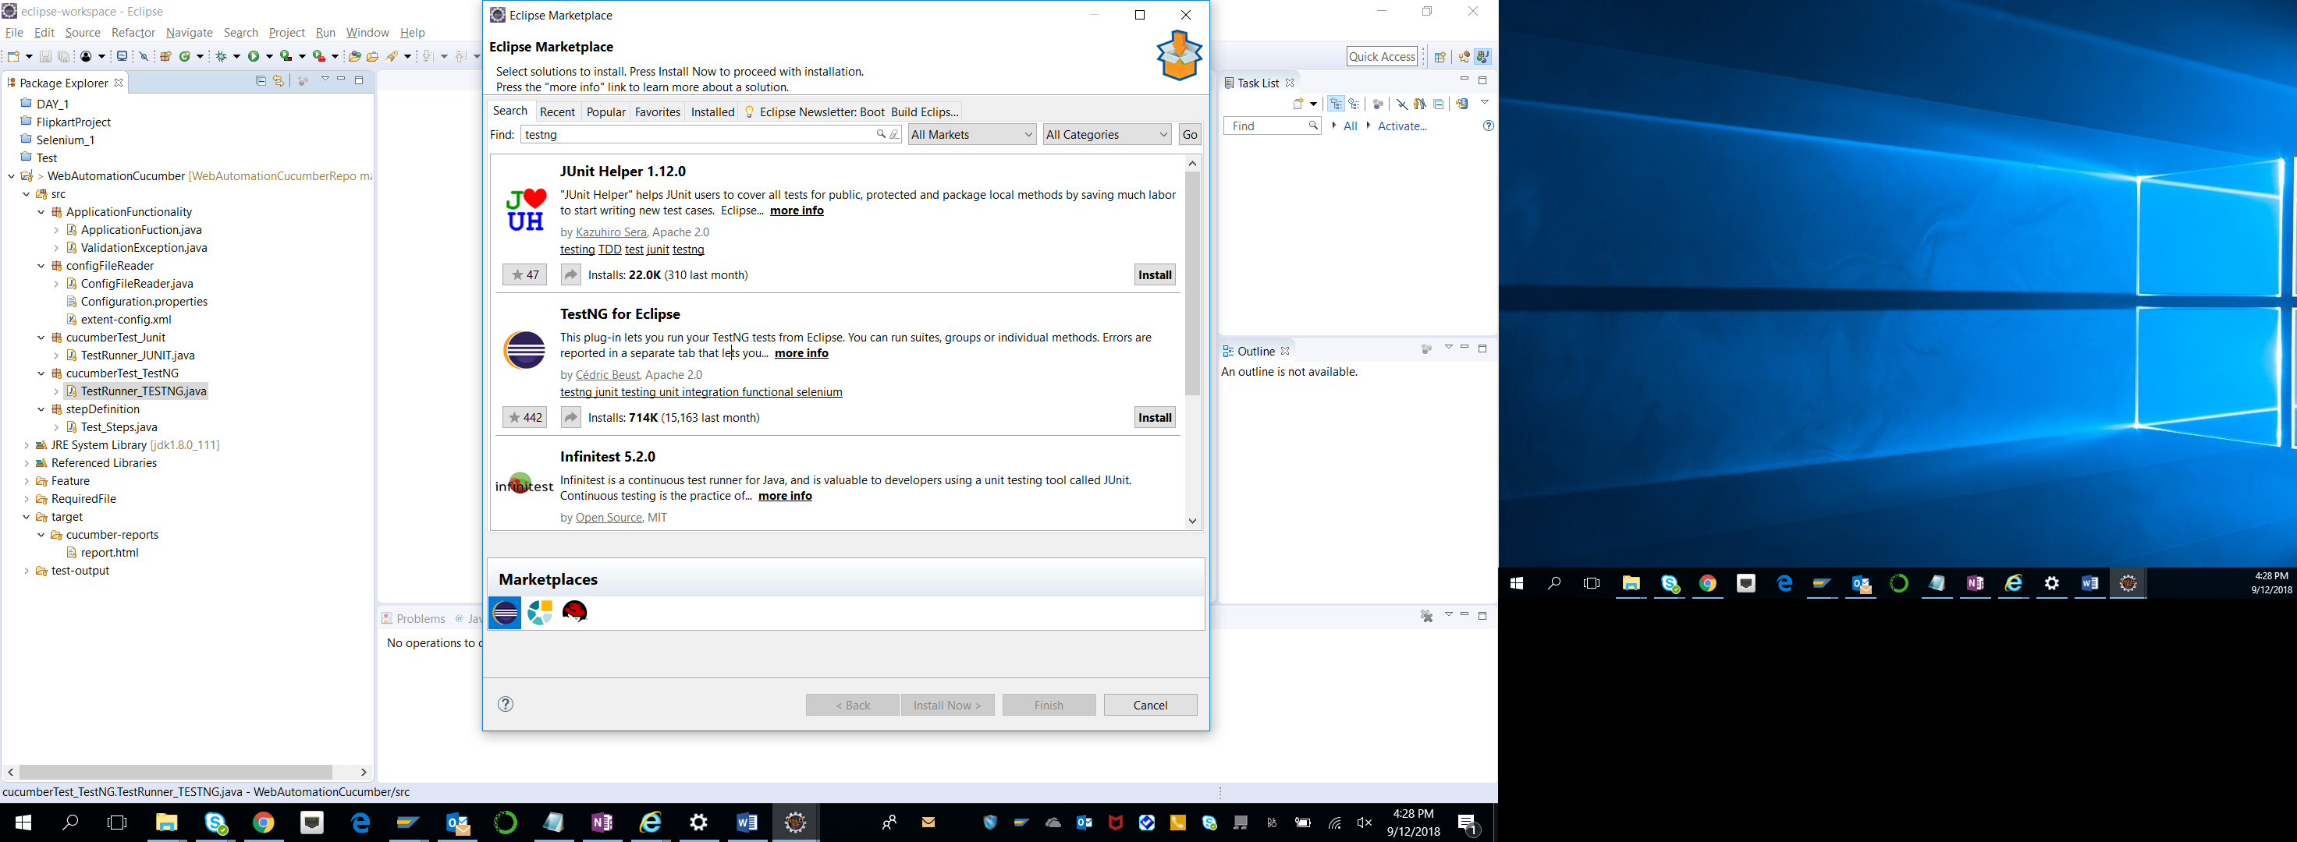

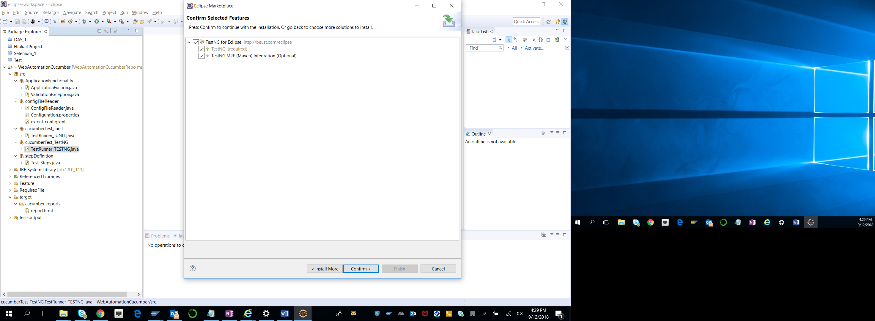

Accept term of installation

Accept certificate popup

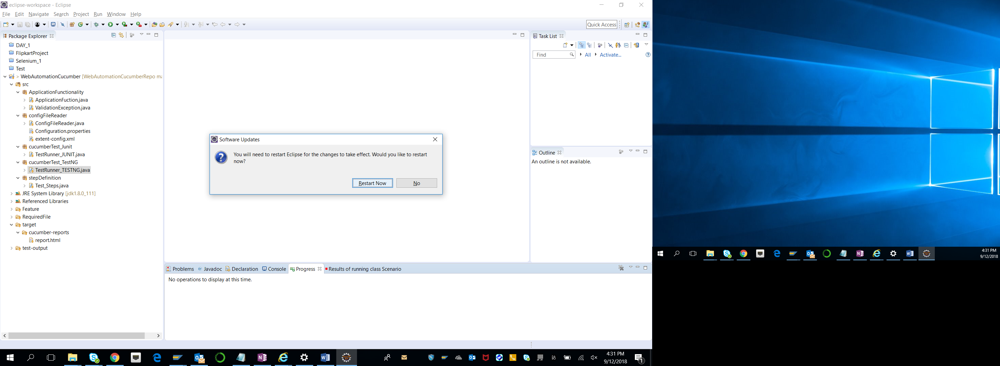

And finally restart eclipse whenever asked.

# Access Cucumber Automation project via git repository

My Automation project git repository link:

<https://github.com/mkshchdhry/WebAutomationCucumberRepo.git>

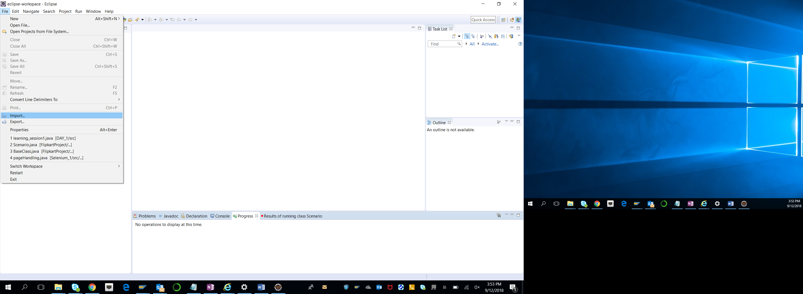

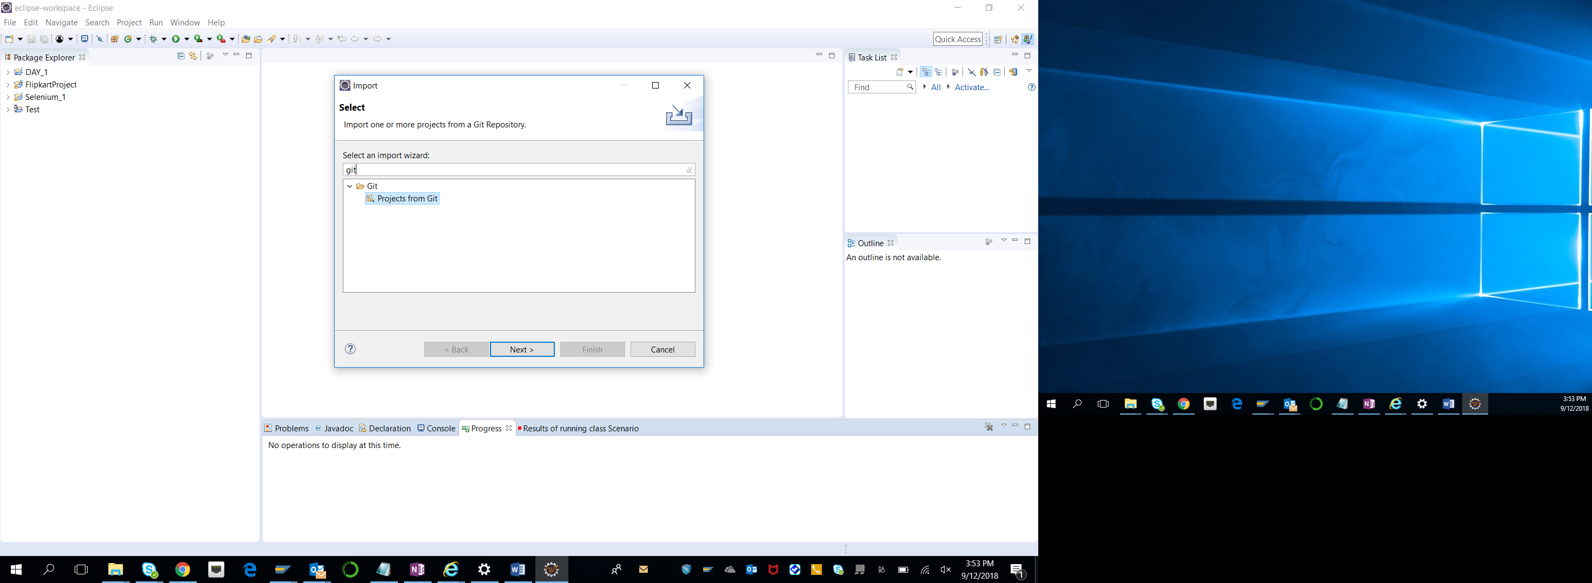

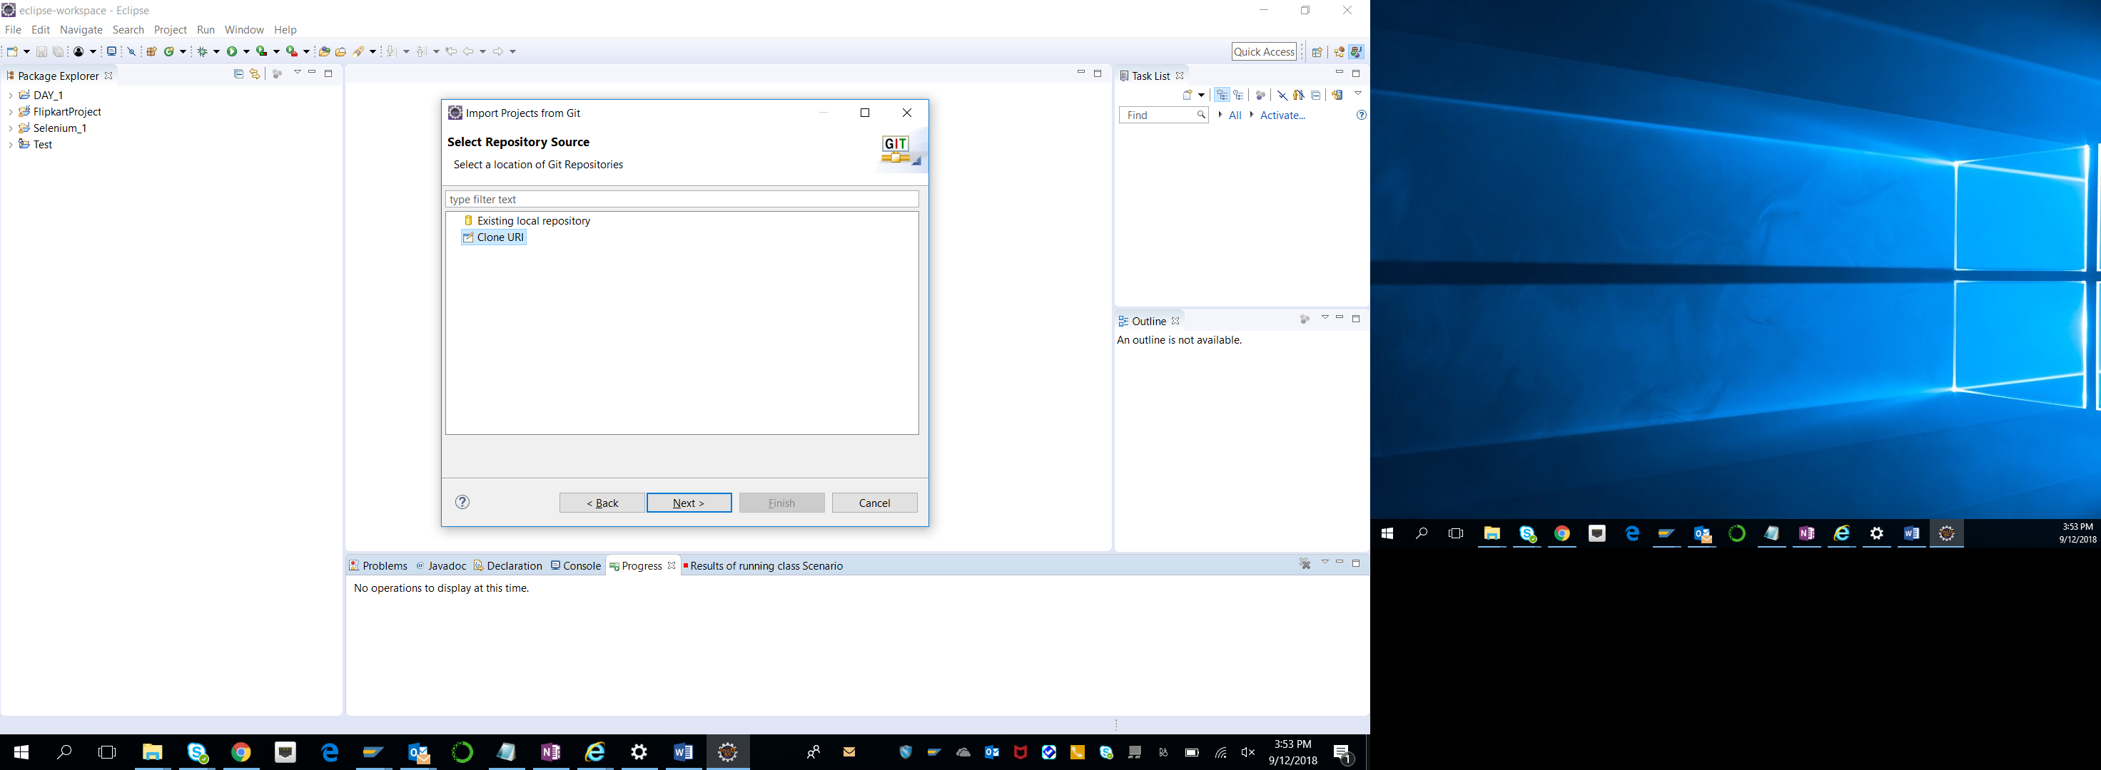

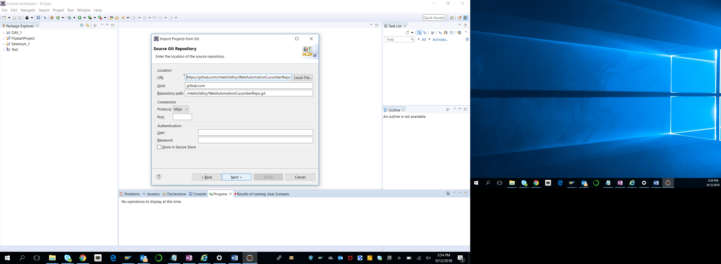

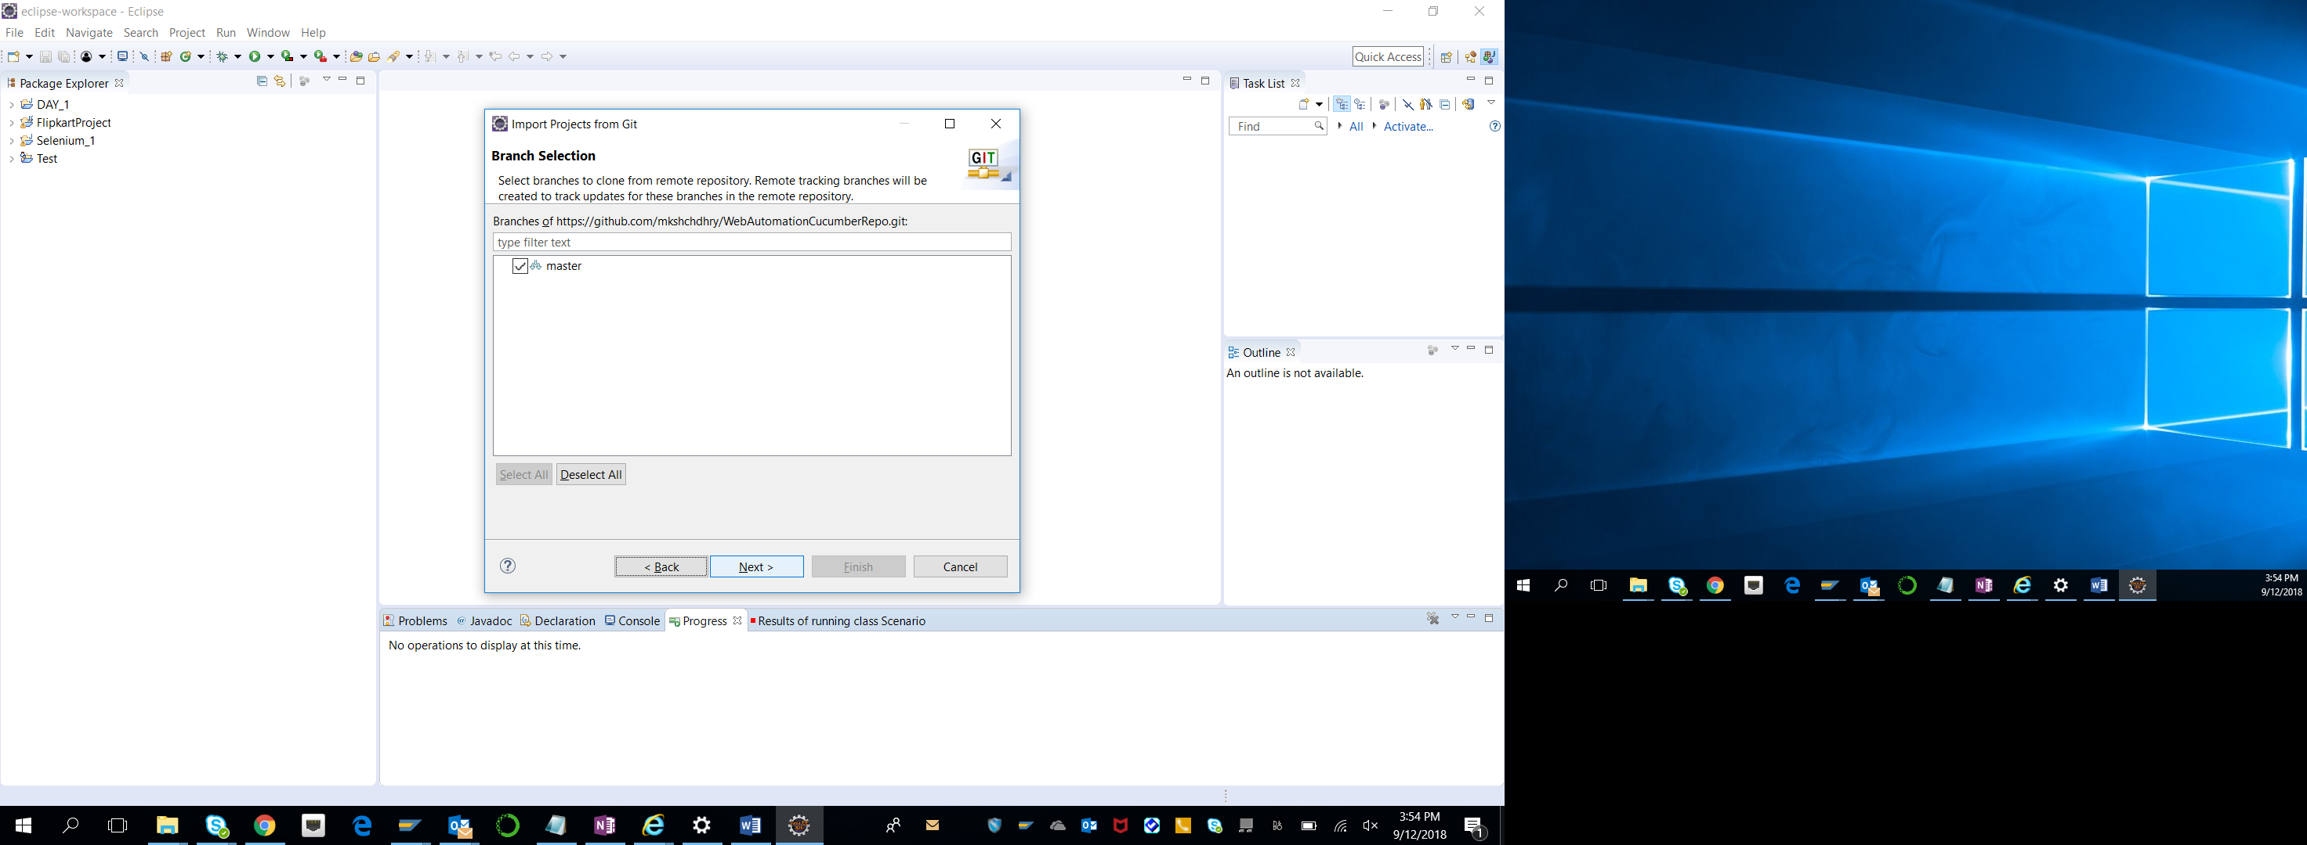

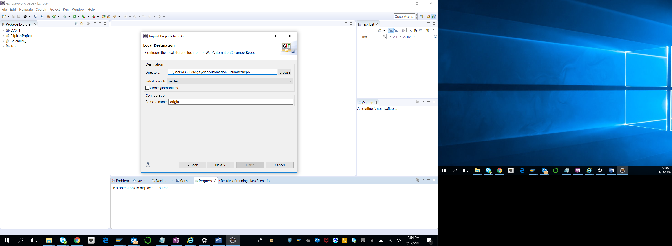

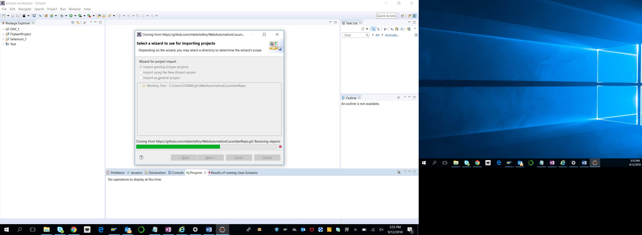

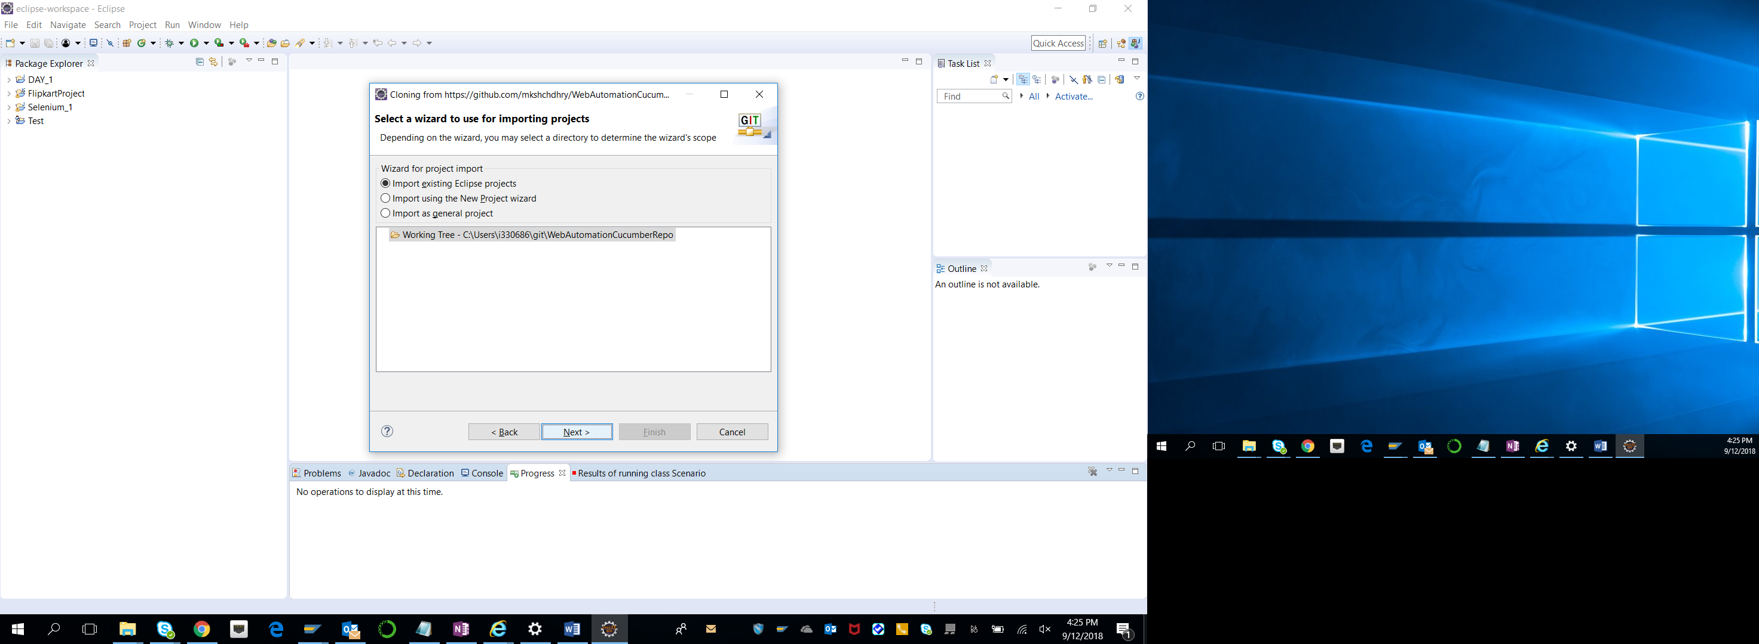

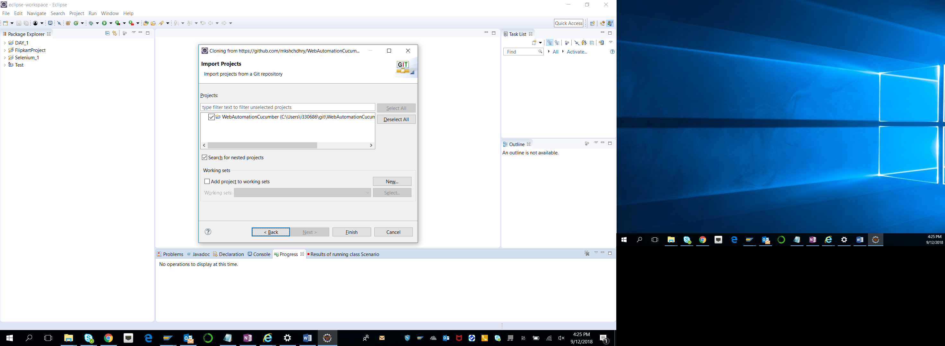

Click on “Finish” Button.

**Now, you can see that project is imported to current Eclipse workspace.**

# Running Cucumber Automation Project

## Step1: Expand and View Project structure

Select any one option from Junit or TestNG for execution.

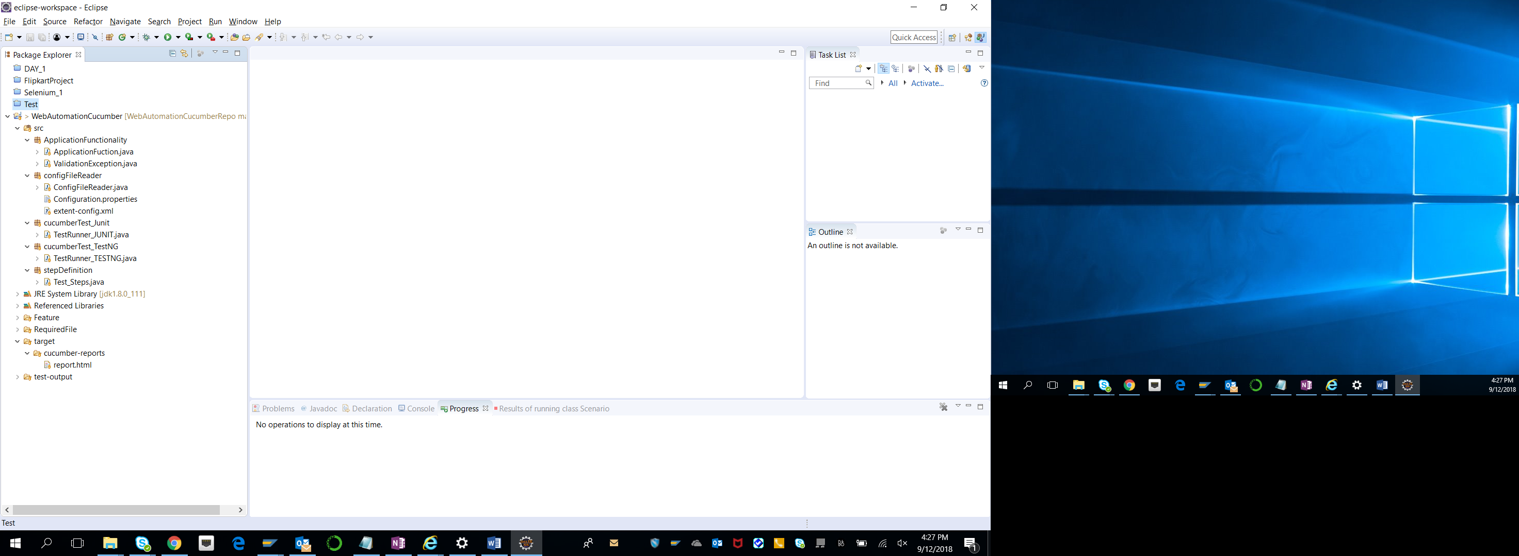

## Step2: Executing Cucumber test via Junit

Right click on “**TestRunner_JUNIT.java**” and Select option Run As 🡺 Junit test

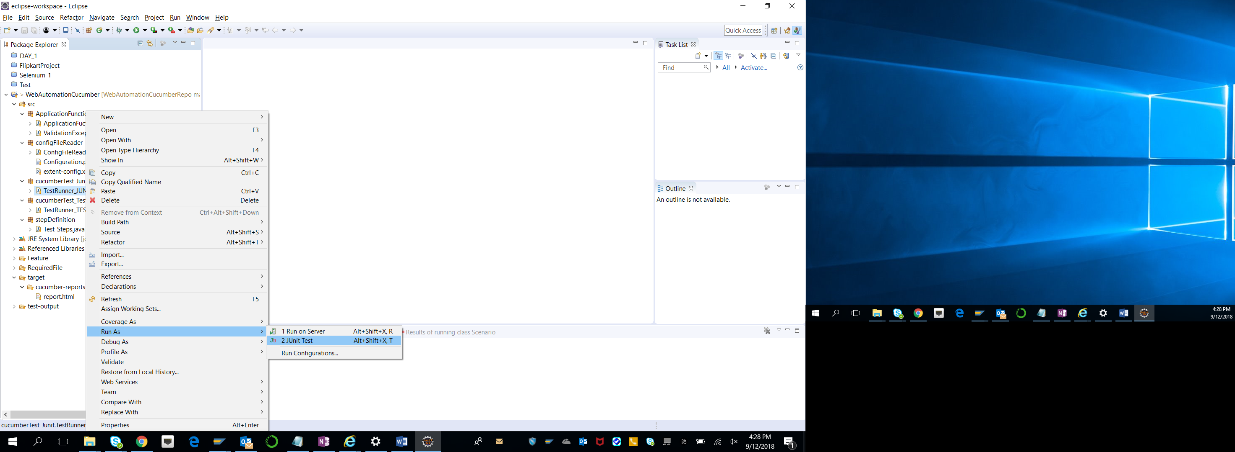

## Step3: Executing Cucumber test via TestNG

Right click on “**TestRunner_TESTNG.java**” and Select option Run As 🡺 TestNG test

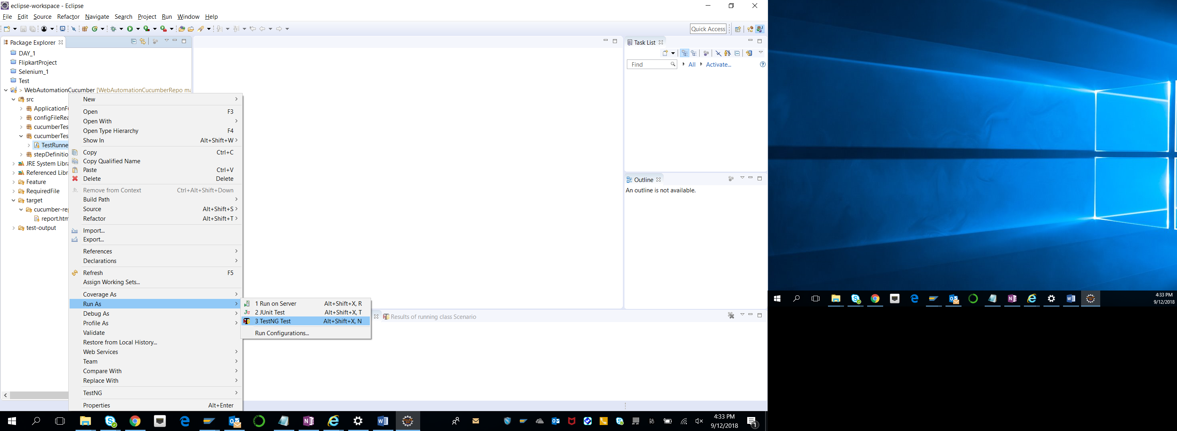

## Step4: Normal Execution and Junit Result

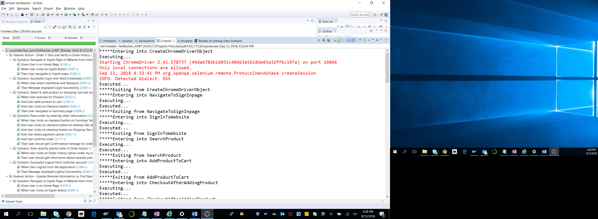

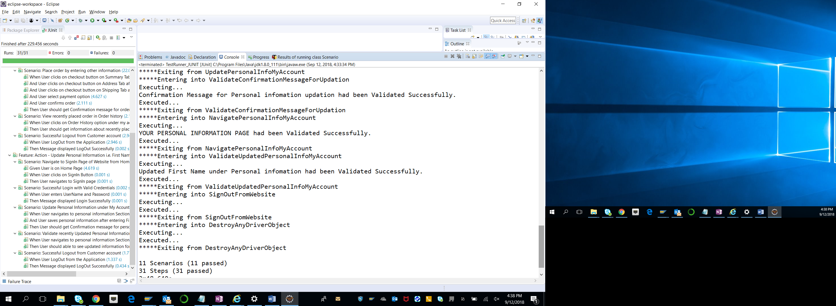

## Step5: View Test Execution report using Extents Report feature.

Select option: target🡺cucumber-reports🡺report.html

Right click on html file and select option: Open With🡺Web Browser

